**Hardware and Software Requirements**

**Hardware Components**

1. **Microcontroller**
   * **Arduino Uno** (Main controller for sensor interfacing and data processing)
   * **ESP8266 Wi-Fi Module** (For cloud connectivity and data upload to ThingSpeak)
2. **Sensors**
   * **DHT11 Sensor** (Measures temperature and humidity)
   * **Water Level Sensor** (Ultrasonic or float-based for flood detection)
   * **Rain Sensor** (Detects rainfall intensity)
3. **Alert & Communication Modules**
   * **SIM800L GSM Module** (Sends SMS alerts to authorities)
   * **Buzzer** (Audible alarm for on-site warnings)
4. **Power Supply**
   * **12V DC Adapter** or **9V Battery** (Primary power source)
   * **Solar Panel (Optional)** (For off-grid deployment)

**Software Requirements**

1. **Programming Tools**
   * **Arduino IDE** (For coding and uploading firmware to Arduino)
   * **Embedded C/C++** (Main programming language for logic implementation)
2. **Cloud & Communication**
   * **ThingSpeak API** (For IoT data logging and visualization)

1. **Libraries Used**
   * **DHT Library** (For DHT11 sensor interfacing)
   * **GSM Library** (For SIM800L SMS functionality)
   * **ESP8266WiFi Library** (For Wi-Fi connectivity)
2. **Third-Party Tools**
   * **Thinkspeak**

**Hardware required**

**ARDUINO UNO**

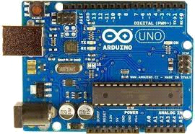

The Arduino Uno is an open-source microcontroller board based on the Microchip ATmega328P microcontroller and developed by Arduino.cc.The board is equipped with sets of digital and analog input/output (I/O) pins that may be interfaced to various expansion boards (shields) and other circuits.The board has 14 digital I/O pins (six capable of PWM output), 6 analog I/O pins, and is programmable with the Arduino IDE (Integrated Development Environment), via a type B USB cable. It can be powered by the USB cable or by an external 9-volt battery, though it accepts voltages between 7 and 20 volts. It is similar to the Arduino Nano and Leonardo.

While the Uno communicates using the original STK500 protocol, it differs from all preceding boards in that it does not use the FTDI USB-to-serial driver chip. Instead, it uses the Atmega16U2 (Atmega8U2 up to version R2) programmed as a USB-to-serial converter.

* **Features of Arduino**

The key features of Arduino have been discussed below as follows:

* Arduino boards are able to read analog or digital input signals from different sensors and turn it into an output such as activating a motor, turning LED on/off, connect to the cloud and many other actions.
* You can control your board functions by sending a set of instructions to the microcontroller on the board via Arduino IDE (referred to as uploading software).
* Unlike most previous programmable circuit boards, Arduino does not need an extra piece of hardware (called a programmer) in order to load a new code onto the board. You can simply use a USB cable.
* Additionally, the Arduino IDE uses a simplified version of C++, making it easier to learn to program.

Finally, Arduino provides a standard form factor that breaks the functions of the micro- controller into a more accessible package

* **Arduino UNO board description**

We chose the Arduino UNO board because it is the most popular board in the Arduino board family. In addition, it is the best board to get started with electronics and coding. Some boards look a bit different from the one given below, but most Arduino have majority of these components in common.

**Fig. 3.1.4 Arduino UNO Board**

The pin configuration of the Arduino UNO Board is discussed in the below Table 3.1.4:

|  |  |
| --- | --- |
| **Pin No.** | **Description** |
|  | **Power USB**: Arduino board can be powered by using the USB cable from your computer. All you need to do is connect the USB cable to the USB connection (1). |
|  | **Power (Barrel Jack):** Arduino boards can be powered directly from the AC mains power supply by connecting it to the Barrel Jack (2). |

|  |  |
| --- | --- |
|  | **Voltage Regulator:** The function of the voltage regulator is to control the voltage given to the Arduino board and stabilize the DC voltages used by the processor  and other elements. |
|  | **Crystal Oscillator:** The crystal oscillator helps Arduino in dealing with time issues. How does Arduino calculate time? The answer is, by using the crystal oscillator. The number printed on top of the Arduino crystal is 16.000H9H. It  tells us that the frequency is 16,000,000 Hertz or 16 MHz |
|  | **Arduino Reset:** You can reset your Arduino board, i.e., start your program from the beginning. You can reset the UNO board in two ways. First, by using the reset button (17) on the board. Second, you can connect an external reset button  to the Arduino pin labelled RESET (5). |
|  | **Pins (3.3, 5, GND, Vin)**  **3.3V (6) :** Supply 3.3 output volt  **5V (7) :** Supply 5 output volt  (Most of the components used with Arduino board works fine with 3.3 volt and 5 volt.)  **GND (8- Ground):** There are several GND pins on the Arduino, any of which can be used to ground your circuit.  **Vin (9) :** Even this pin can be used to power the Arduino UNO board  from an external power source, like AC mains power supply. |
|  | **Analog pins:** This board has six analog input pins A0 to A5. These pins can read  the signal from an analog sensor like the humidity sensor or temperature sensor and convert it into a digital value that can be read by the microprocessor. |
|  | **Main microcontroller:** Each Arduino board has its own microcontroller (11). You can assume it as the brain of your board. The main IC (integrated circuit) on the Arduino is slightly different from board to board. The microcontrollers are usually of the ATMEL Company. You must know what IC your board has before loading up a new program from the Arduino IDE. This information is available on the top of the IC. For more details about the IC construction and functions,  you can refer to the data sheet. |

|  |  |
| --- | --- |
|  | **ICSP pin:** Mostly, ICSP (12) is an AVR, a tiny programming header for the Arduino consisting of MOSI, MISO, SCK, RESET, VCC, and GND. It is often referred to as an SPI (Serial Peripheral Interface), which could be considered as an "expansion" of the output. Actually, you are slaving the output device to the  master of the SPI bus. |
|  | **Power LED indicator:** This LED should light up when you plug your Arduino into a power source to indicate that your board is powered up correctly. If this light does not turn on, then there is something wrong with the connection. |
|  | **TX and RX LEDs:** On your board, you will find two labels: TX (transmit) and RX (receive). They appear in two places on the Arduino UNO board. First, at the digital pins 0 and 1, to indicate the pins responsible for serial communication. Second, the TX and RX led (13). The TX led flashes with different speed while sending the serial data. The speed of flashing depends on the baud rate used by  the board. RX flashes during the receiving process. |
|  | **Digital I/O:** The Arduino UNO board has 14 digital I/O pins (15) (of which 6 provide PWM (Pulse Width Modulation) output. These pins can be configured to work as input digital pins to read logic values (0 or 1) or as digital output pins to drive different modules like LEDs, relays, etc. The pins labelled “~” can be  used to generate PWM. |
|  | **AREF:** AREF stands for Analog Reference. It is sometimes, used to set an external reference voltage (between 0 and 5 Volts) as the upper limit for the  Analog input pins. |

**Table 3.1.4 Pin Configuration of Arduino UNO Board**

**DHT11 - Temprature and Humidity Sensor Module**

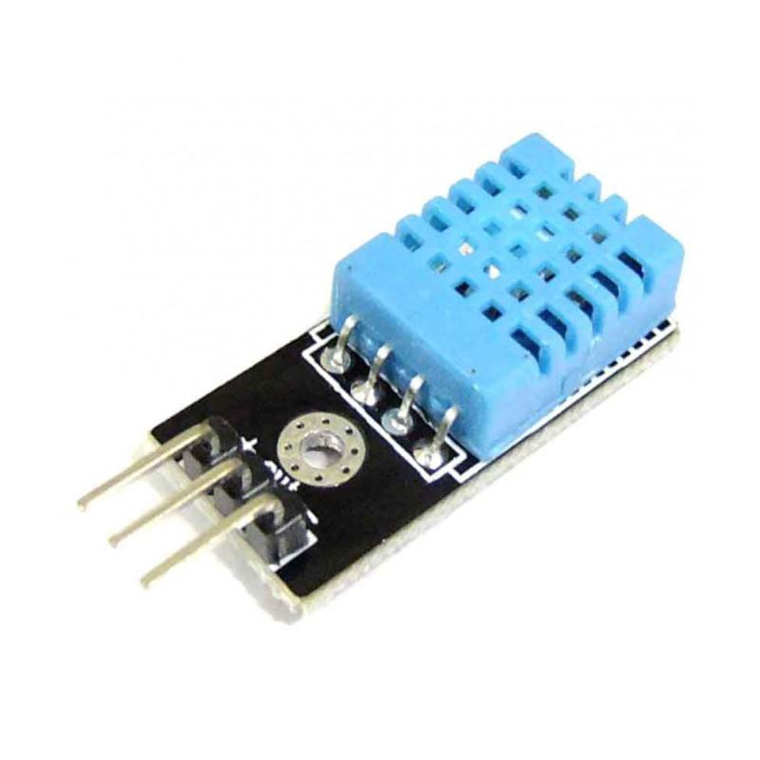

DHT11 is a Humidity and Temperature Sensor, which generates calibrated digital output. DHT11 can be interface with any microcontroller like Arduino, Raspberry Pi, etc. and get instantaneous results. DHT11 is a low cost humidity and temperature sensor which provides high reliability and long term stability.

It uses a capacitive humidity sensor and a thermistor to measure the surrounding air, and outputs a digital signal on the data pin (no analog input pins needed). Its very simple to use, and libraries and sample codes are available for Arduino and Raspberry Pi.

This module makes is easy to connect the DHT11 sensor to an Arduino or microcontroller as includes the pull up resistor required to use the sensor. Only three connections are required to be made to use the sensor - Vcc, Gnd and Output.

It has high reliability and excellent long-term stability, thanks to the exclusive digital signal acquisition technique and temperature & humidity sensing technology.

**Specifications:-**

* Power Supply： 3.3~5.5V DC
* Output： 4 pin single row
* Measurement Range： Humidity 20-90%RH， Temperature 0~50℃
* Accuracy： Humidity +-5%RH， Temperature +-2℃
* Resolution： Humidity 1%RH， Temperature 1℃
* Interchangeability： Fully Interchangeable
* Long-Term Stability： <±1%RH/year

**Pin Description:-**

* Pin 1:     Power +Ve (3.3VDC to 5.5VDC Max wrt. GND)
* Pin 2:     Serial Data Output
* Pin 3:     Power Ground or Power –Ve

**NODE MCU**

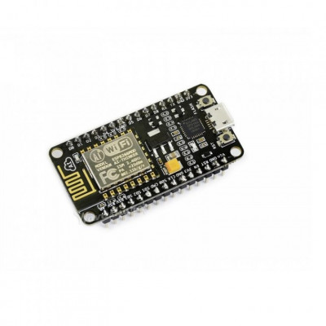

The ESP8266 NodeMCU CP2102 board has ESP8266 which is a highly integrated chip designed for the needs of a new connected world. It offers a complete and self-contained Wi-Fi networking solution, allowing it to either host the application or to offload all Wi-Fi networking functions from another application processor.

[**ESP8266**](https://robu.in/product-tag/esp8266/) **has powerful on-board processing and storage capabilities that allow it to be integrated with the** [**sensors**](https://robu.in/product-category/sensors/) **and other application-specific devices through its GPIOs with minimal development up-front and minimal loading during runtime. Its high degree of on-chip integration allows for minimal external circuitry, and the entire solution, including the front-end module, is designed to occupy minimal PCB area.**

The [ESP8266 NodeMCU](https://robu.in/product-tag/nodemcu-esp8266/) development board – a true plug-and-play solution for inexpensive projects using [WiFi](https://robu.in/product-tag/wifi/). The module arrives pre-flashed with [NodeMCU](https://robu.in/product-tag/nodemcu/) firmware so they’re ready to go – just install your USB driver (below). ESP-12 Lua Nodemcu WIFI Dev Board Internet Of Things board contains a full ESP8266 WiFi module with all the GPIO broken out, a full USB-serial interface, and a power supply all on the one breadboard-friendly package.

*This board is pre-flashed with* [*NodeMCU*](https://robu.in/product-tag/nodemcu/) *– a Lua-based firmware for the ESP8266 which allows easy control via a neat scripting language – Lua – so you’re ready to go in just a few minutes.  
The ESP-12 Lua NodeMCU WIFI Dev Board* [*Internet Of Things*](https://robu.in/product-category/wireless/) *with ESP8266 is an all-in-one* [*microcontroller*](https://robu.in/product-category/arduino-2/arduino/) *+ WiFi platform that is very easy to use to create projects with* [*WiFi*](https://robu.in/product-category/wireless/wifi/) *and* [*IoT (Internet of Things)*](https://robu.in/product-category/wireless/) *applications.*

*The board is based on the highly popular ESP8266 WiFi Module chip with the ESP-12 SMD footprint. This WiFi development board already embeds in its board all the necessary components for the ESP8266 (ESP-12E) to program and upload code. It has a built-in USB to serial chip upload codes, 3.3V regulator, and logic level converter circuit so you can immediately upload codes and connect your circuits.*

**Features :**

1. 11 b/g/n Wi-Fi Direct (P2P), soft-AP
2. Integrated TCP/IP protocol stack
3. Open-source, Interactive, Programmable, Low-cost, Simple, Smart, Wi-Fi-enabled
4. Arduino-like hardware IO
5. Integrated low-power 32-bit CPU
6. Advanced API for hardware IO, which can dramatically reduce the redundant work for configuring and manipulating hardware.
7. Code like Arduino, but interactively in Lua script.
8. Nodejs style network API
9. Event-driven API for network applications,
10. which facilitates developers writing code running on a 5mm*5mm sized MCU in Nodejs style.
11. Greatly speed up your IOT application development process.
12. Lowest cost WI-FI
13. Less than WI-FI MCU ESP8266 integrated and easy to prototyping development kit.
14. We provide the best platform for IoT application development at the lowest cost.
15. Integrated TR switch, balun, LNA, power amplifier, and matching network
16. Integrated PLL, regulators, DCXO, and power management units
17. Onboard USB to serial chip to easily program and upload codes from the Arduino IDE
18. Embeds logic level converter circuits
19. Has an onboard 3.3V regulator to ensure enough power to function as your go-to WiFi chip!
20. Easy access to the GPIO pins for easy prototyping
21. Easy to use breadboard friendly form factor
22. Voltage Regulator / Converter, excellent DC to DC conversion, super-efficient

**Battery**

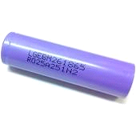

This LG INR18650 M26 2600mAh Lithium-Ion Battery gives value for your money. It comes with a rated voltage of 3.7 volts and a capacity of 2600mAh. It is a single cell, compact, and powerful battery cell with 2600 mAh capacity. It is very convenient to install in your project to fulfill the 3.7 Volt requirement with high capacity.

The battery terminals can use in any compatible battery adapter/holder or it can be permanently soldered to your applications power source wires.

Features :

High energy density

High working voltage for single battery cells.

Pollution-free

Long cycle life

self-discharge.

Lightweight, small size

Shape: Cylindrical Battery

Battery Type: Lithium-Ion Battery

High performance and capacity

Flat top to suit many devices fitting.

**High Sensitivity Water Level Sensor**

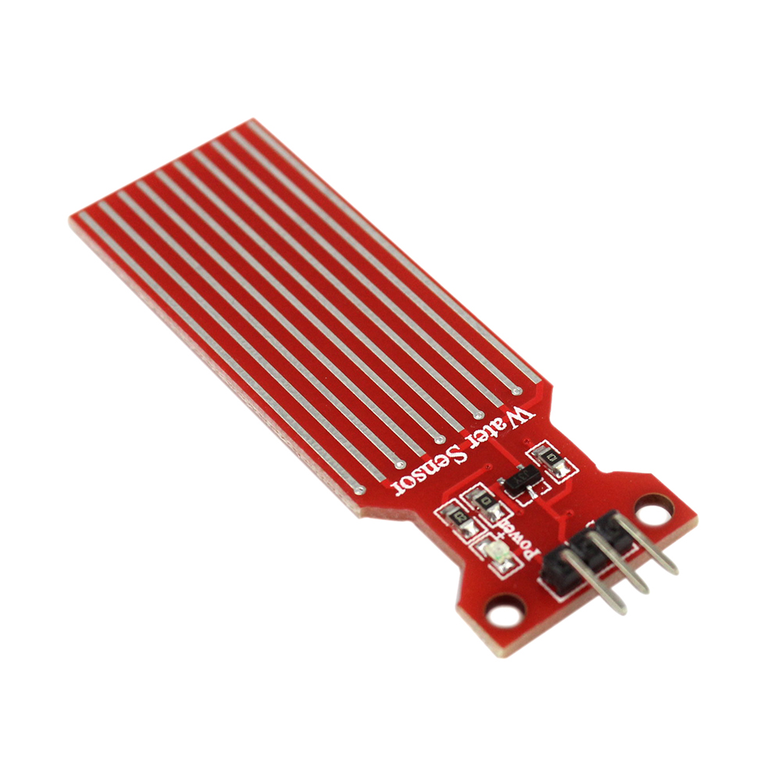

**High Sensitivity Water Level Sensor compatible with Arduino**

Are you tired of inaccurate water level measurements in your Arduino projects? Say hello to the Water Level Depth Detection Sensor for Arduino – your ultimate solution for precise and reliable water level detection. With an operating voltage of DC3-5V and an operating current of less than 20mA, this sensor ensures optimal performance without draining your power supply.  
  
Its analog detection area of 40x16mm allows for easy and direct conversion of water to analog signals, enabling your Arduino development board to achieve the desired level alarm effect. Whether you're working on automated irrigation systems, hydroponics, or water tanks monitoring, this sensor's high level/drop recognition capability will provide you with accurate readings every time.  
  
Unleash the true potential of your Arduino projects with this cost-effective and user-friendly [water level sensor](https://robocraze.com/blogs/post/what-is-a-water-sensor). Don't let inaccuracies hold you back – take the plunge and elevate your projects to new heights of precision and efficiency!

When it comes to choosing the right water level sensor for your Arduino projects, ease of integration and performance are crucial factors. Our Water Level Depth Detection Sensor for Arduino checks all the boxes and more!  
  
With its streamlined design and analog output, setting up and reading data from the sensor is a breeze. You'll be amazed at how effortlessly it communicates with your Arduino board, making the integration process smooth and hassle-free.  
  
Crafted with high-quality materials, this sensor guarantees durability and long-lasting performance, ensuring it stands the test of time in any project you undertake. Its reliable performance will give you the confidence to monitor water levels accurately and make data-driven decisions.  
  
Embrace the power of precise water level detection and experience the convenience of working with a sensor that complements your Arduino projects seamlessly.

This High Sensitivity Water Sensor can easily change the water size to an analog signal, and output analog value can directly be used in the program function, then to achieve the function of water level alarm. This item has low power consumption, and high sensitivity, which are the biggest characteristics of this module. The High Sensitivity Water Sensor can be compatible with [Arduino UNO](https://robocraze.com/products/arduino-uno-original), [Arduino mega2560](https://robocraze.com/products/arduino-mega-original), Arduino ADK etc.

Buy Water Level Sensor now which is High Sensitivity and compatible with Arduino and elevate your Arduino projects to new levels of precision and efficiency. Order now and experience the convenience of working with a sensor that complements your projects seamlessly!

Also, read our blog on the [Water Level Sensor](https://robocraze.com/blogs/post/what-is-a-water-sensor) explaining the different types of water sensors, working, and applications.

**Pin definition :**

* "S" stand for signal input
* "+" stand for power supply
* "-" stand for GND

**Applications of Water Level Sensor:**

* Water level measurement: The water level sensor can be used to measure the water level in tanks, reservoirs, or other containers
* Sump pit monitoring: It can be used to monitor the water level in sump pits to prevent flooding
* Rainfall detection: The sensor can detect rainfall and be used in weather monitoring systems
* Leak detection: It can be used to detect water leaks in pipes, plumbing systems, or appliances
* Irrigation control: The water level sensor can be used to monitor the water level in irrigation systems and automate the watering process
* Aquarium water level monitoring: It can be used to monitor the water level in aquariums and ensure proper water conditions for aquatic life
* Flood warning systems: The sensor can be used in flood warning systems to monitor water levels in rivers, streams, or flood-prone areas
* Water level control in industrial applications: It can be used to control the water level in industrial processes or equipment
* Water level detection in wells: The sensor can be used to monitor the water level in wells and ensure an adequate water supply
* Water level detection in smart home systems: The sensor can be integrated into smart home systems to monitor water levels and send alerts or automate actions

Raindrops Detection Sensor Module

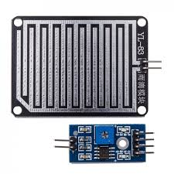

The Raindrops Detection sensor module is used for rain detection. It is also for measuring rainfall intensity. Rain sensor can be used for all kinds of weather monitoring and translated into output signals and AO.

*Raindrops Detection Sensor Module Rain Weather Module for* [***Arduino***](https://robu.in/product-category/arduino-2/arduino/)*, etc. Rain sensor can be used to monitor a variety of weather conditions and turned into several fixed output signal and Analog output.*

**It includes a printed circuit board (control board) that “collects” the raindrops. As raindrops are collected on the circuit board, they create paths of parallel resistance that are measured via the op-amp. The lower the resistance (or the more water), the lower the voltage output. Conversely, the less water, the greater the output voltage on the analog pin. A completely dry board, for example, will cause the module to output 5V.**

The module includes a rain board and a control board that is separate for more convenience. It has a power indicator LED and an adjustable sensitivity through a potentiometer. The module is based on the LM393 op-amp.

**Features :**

1. The LM393, use of the wide voltage comparator
2. Provide both digital and analog output
3. Output LED indicator
4. Compatible with [Arduino](https://robu.in/product-category/arduino-2/arduino/)
5. TTL Compatible
6. The sensor uses the high-quality FR – 04 double material, the large area of 5.5 * 4.0 CM
7. Treatment of nickel plating and surface, have fight oxidation, electrical conductivity, and life has more superior performance
8. The comparator output, signal clean, good waveform, driving ability is strong, for more than 15 mA;
9. With potentiometer sensitivity adjustment
10. The output format: digital switch output (0 and 1) and analog AO voltage output;